TriJam 118 - Toxicity

Game overview

Game name
Toxic Shooter

Game concept
Absorb 2 types of enemy’s projectile to form a toxic projectile to shoot.
Destroy all enemies.

Genre
Top-down shooter.

Gameplay
The Player starts in the middle of the screen and he can move around in a restricted space. The Player must absorb the enemies’ projectiles which contain different substances. Combining two different substances, can create a toxicant substance that the Player uses as a projectile to fight back the enemies.
The enemies randomly appear from outside of the restricted player-movement area and they randomly attack the Player with substances.
There are two zones around the player, zone A is for the first substance and B for the second. Using his controls, the player must absorb the substance when it is inside its equivalent zone. Failing to do so, will result in player taking damage.

Concept Gameplay
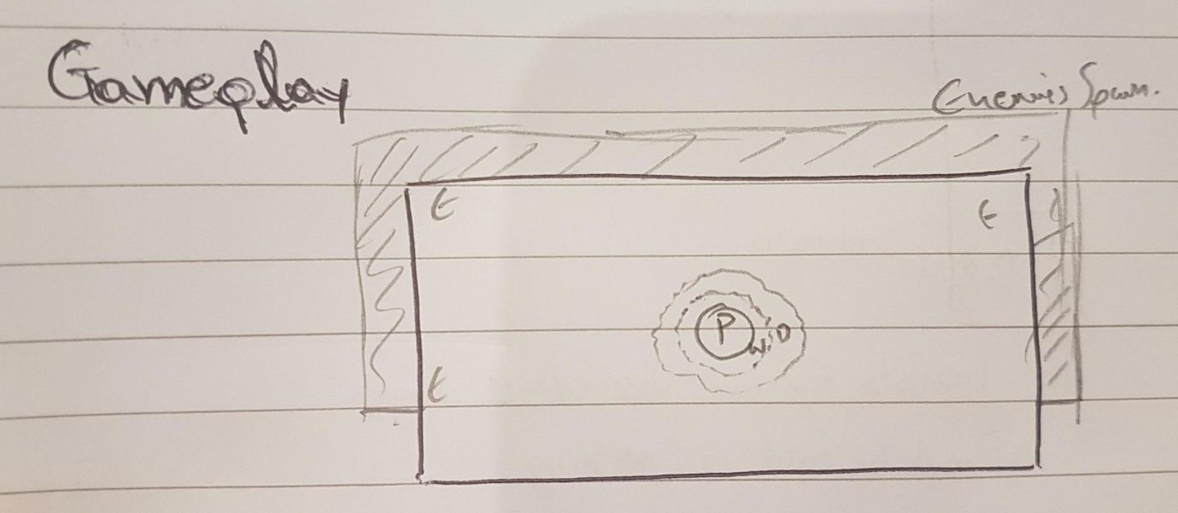

Winning Condition
Scoring System. The Player wins by constantly trying to beat his previous score.

Losing Condition
Health. The Player’s health reaches 0. The Player loses health when he absorbs a substance which is not within its zone or when an enemy’s projectile hits him/her.

Look and feel.
Simplistic cartoony characters and bright colours.
The game will be a top-down experience with a static camera view. The player can move around the area, but the camera won’t follow him/her. The enemies spawn outside the camera view but they move in and start attacking.

Game Mechanics

Mechanics
Shooting, Absorbing, Crafting, Object avoidance

Control system
The Player will be using WASD for his/her movement and the mouse buttons to absorb and shoot projectiles.

Goals and objectives
The long-term objective is to achieve exceedingly high score.
The short-term objectives are to avoid the enemy’s attacks or absorb them to fight back.

Characters

Player

Health
The Player will start with maximum health at 100 and 3 lives. Depending on the enemy, and how far the game is, the Player will get affected by their attacks differently.
There will be healing power-ups throughout the game level if the Player performs well.

Attacks
The Player will be firing projectiles which deal damage depending on his/her progress in the game.
The Player will also have some power-ups attacks that he/she will be able to use against enemies.

Enemies

Health
The enemies come in waves. The enemies deal with damage differently, depending on the wave they appear in.

Attack
The enemies come in waves. Each wave is more difficult than the previous one in a unique way. They shoot 2 projectiles at random rate and in random order.

Visual UI/UX

HUD
There is a canvas that will be showing the player’s health, powerups, score, kills, toxic ammo.

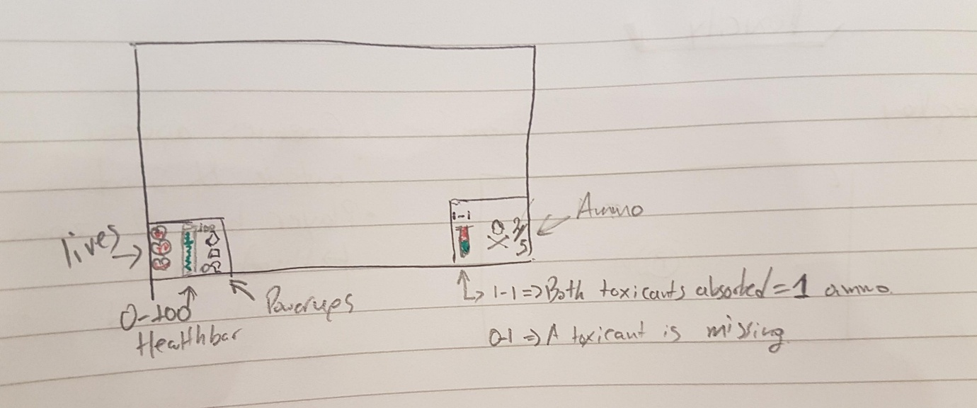
Concept UI

Tech
The project will be made using Unity 2021.1.4f1 and Visual Studio 2019.

